- Access https://console.cloud.google.com/ and register an account, this should be simple if you are using a Gmail account.
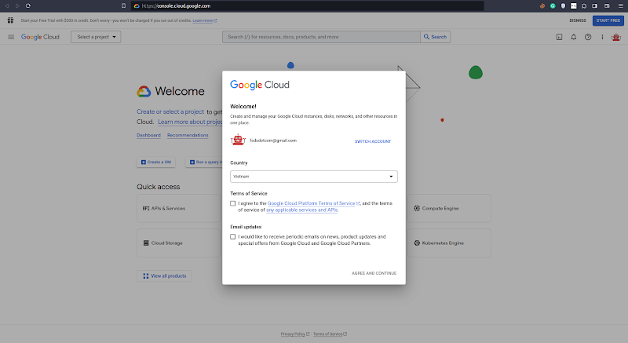
- Click the 2 checkboxes Terms of Service and Email updates, then hit AGREE AND CONTINUE
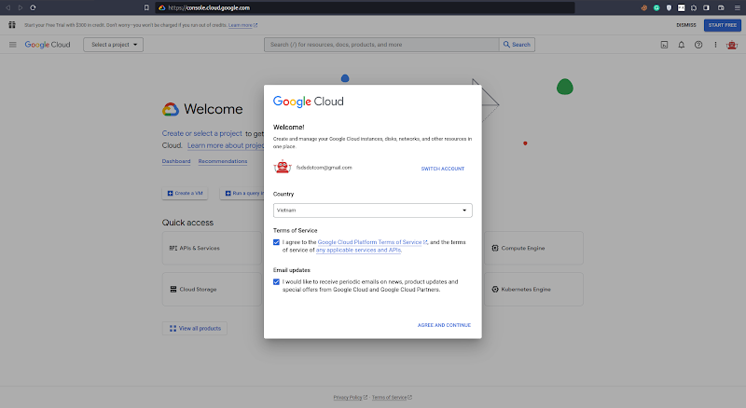
- Click Create a VM
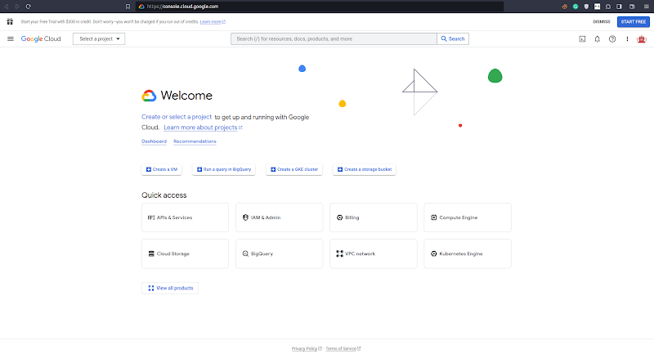
- Hit CREATE PROJECT
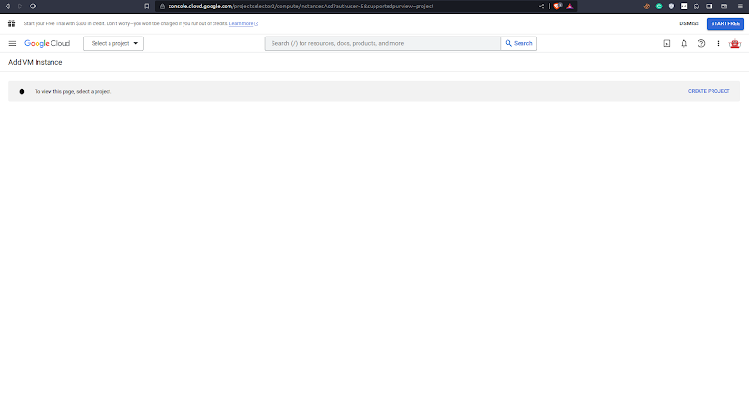
- Fill Project name (for example, MLE course), and hit Create
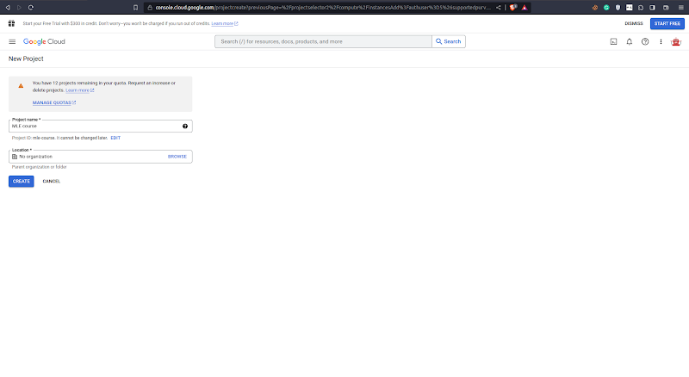￼
- Click CREATE BILLING ACCOUNT
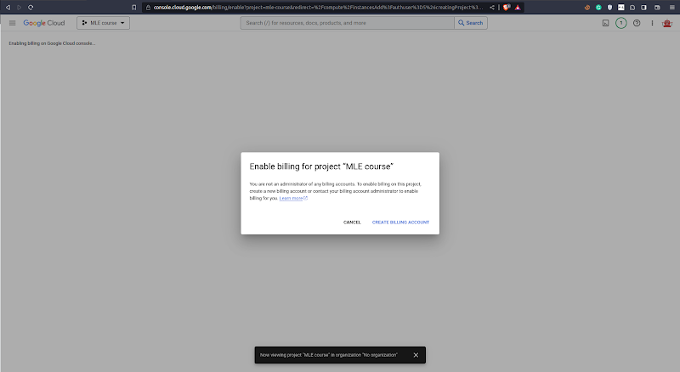
- Under What best describes your organization or needs?, select Startup (or whatever), click the check box under Terms of Service, and hit Continue.
Note: In this case, I have a work email, so I fill my work email under Apply for additional credits (optional) to get an additional $100 in Free Trial credits. If you don't have it, just leave it empty.
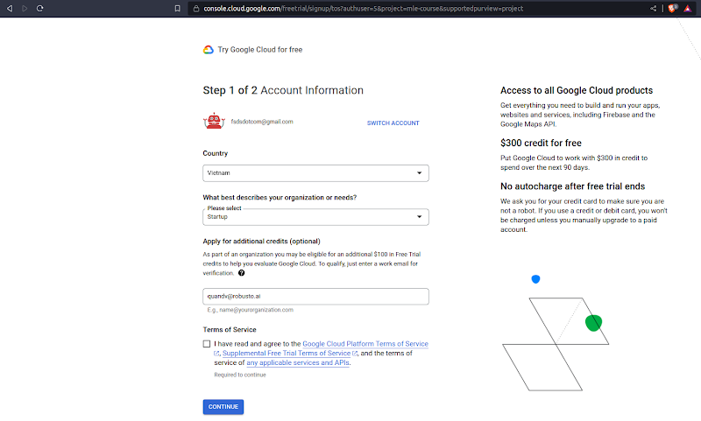
- Fill in your payment information and hit START MY FREE TRIAL
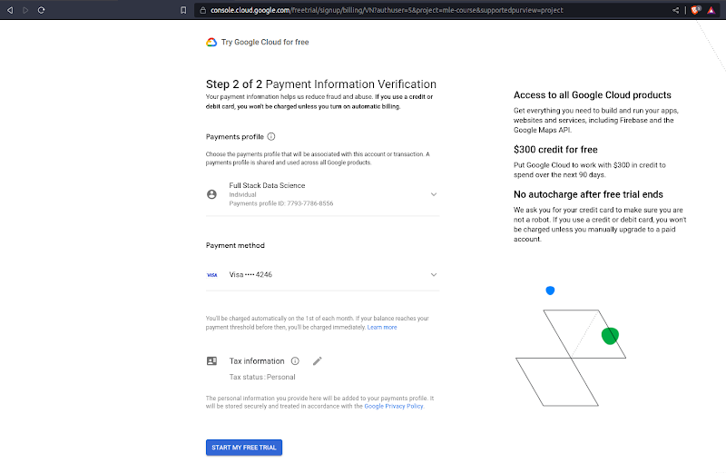
- Cool! We now have access to our free trial, simply click the CLOSE button to close the Welcome! popup.
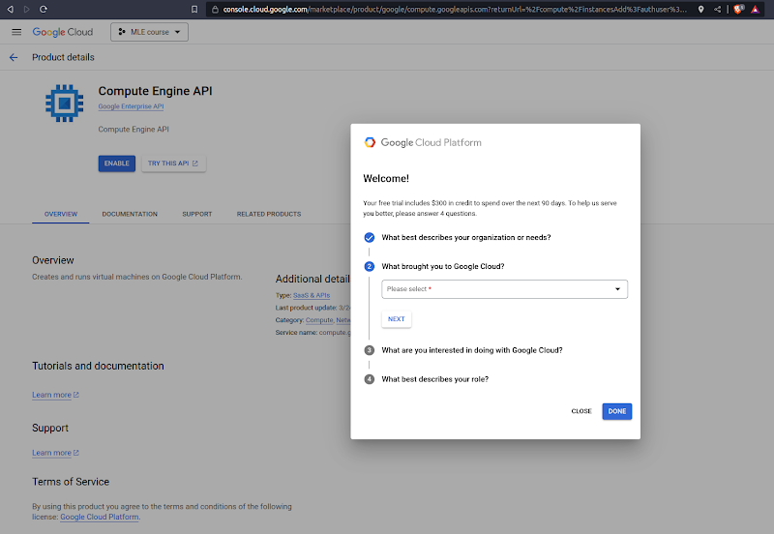
- Hit the blue ENABLE button
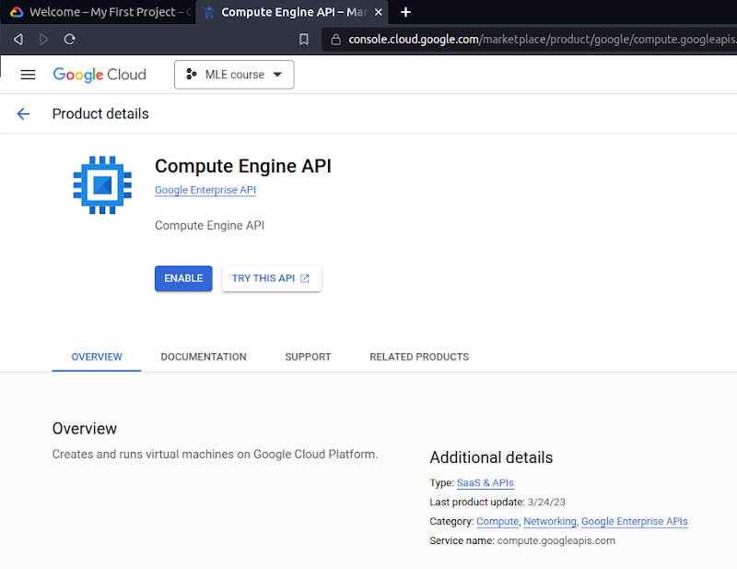
We can see Google is helping us to enable it in the Notifications (click the bell button). Please wait for a while.
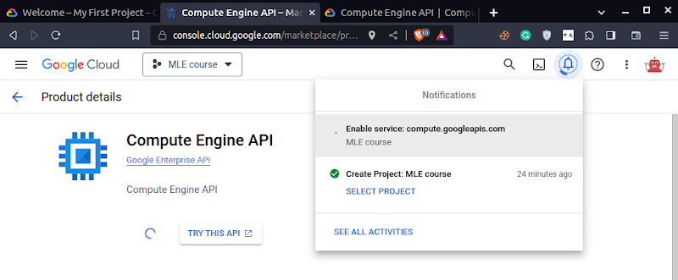
- Now, you can see the page Create an instance similar to this.
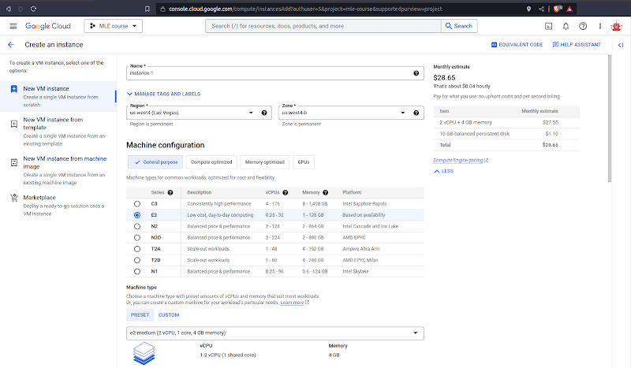
- You can play around with different Series under Machine configuration, for example, select N2D, which is a popular choice and you can see the Monthly estimate has been updated to $56.67 at the top right corner. If you use this VM for development (instead of using a local machine), I suggest using an E2 machine (e.g. e2-standard-8).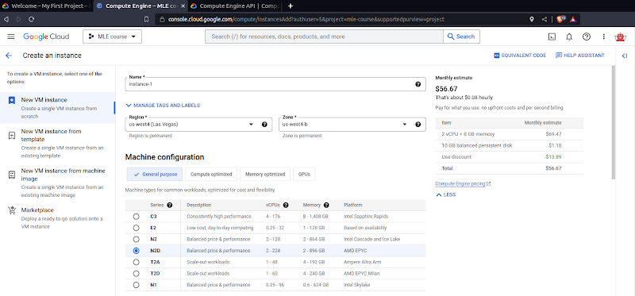
For now, let’s use Series E2!
- Change the Machine type to e2-micro, which has only 1 core and 1 GB of memory so we can not do much with it, but don’t worry, we can upgrade it later.
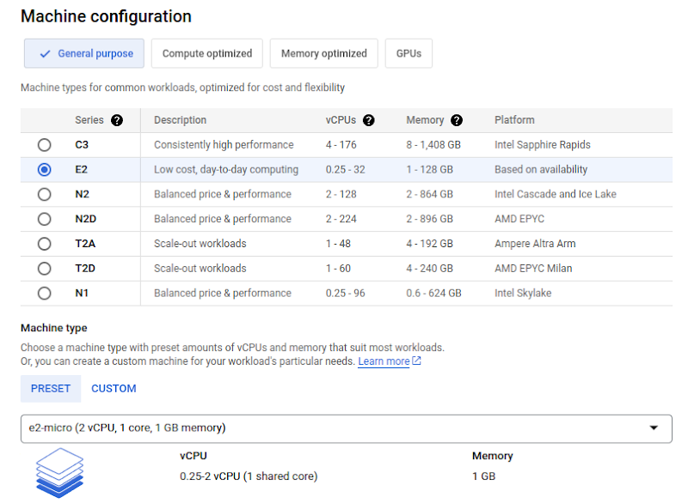
and hit CREATE at the bottom
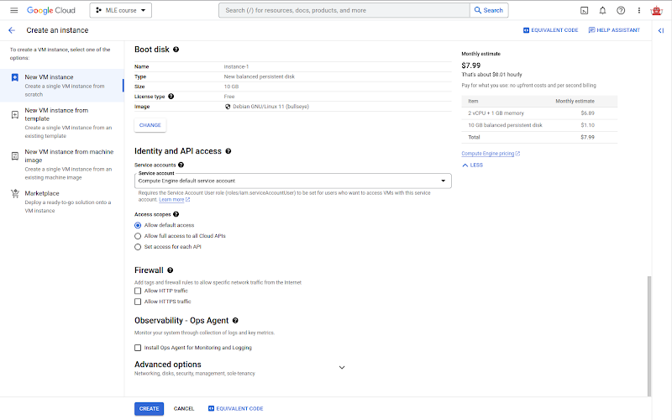
Hint: If you click the button EQUIVALENT CODE you will see a tab open on the right-hand side with 3 tabs: COMMAND LINE, REST, TERRAFORM. These 3 are the other 3 different ways to create the instance (or VM). But ignore them for now.
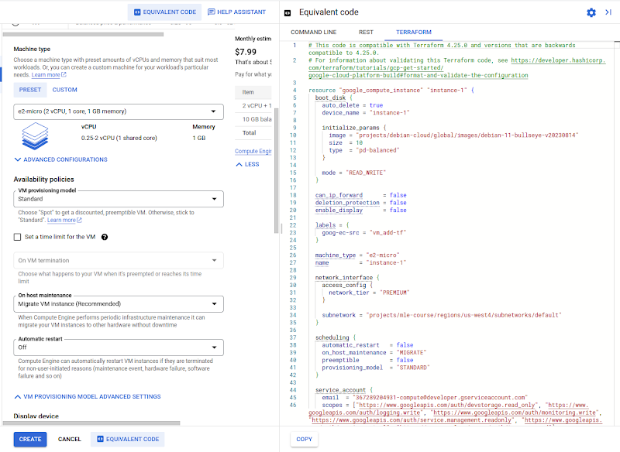
- After hitting the blue CREATE button and waiting for a while, you will see that instance-1 has been created with the green tick. So far so good =)).
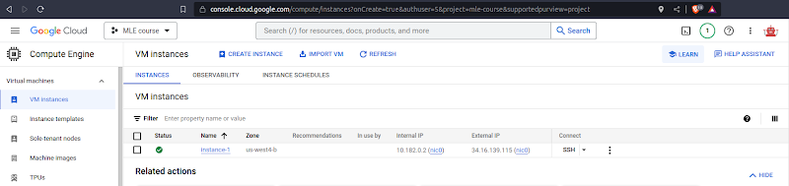
- Now, let’s find a way to access this instance via SSH.
First, check if we can connect to the External IP via port 22 by using telnet on your local terminal. You can see I use my External IP 34.16.139.115, but you will be different, please be careful. OK, connected!
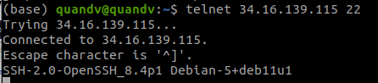Select
- Select Metadata under Settings
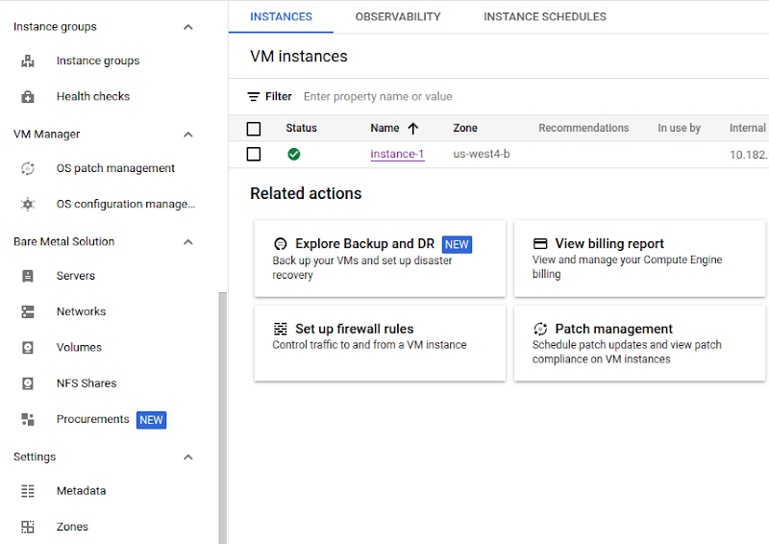
- Select the tab SSH KEYS and click the button + ADD ITEM (or ADD SSH KEY if you don’t see the + ADD ITEM button)
- Generate your SSH key
Open your local terminal, type `ssh-keygen` and type Enter to die until Overwrite (y/n) type y, then continue to Enter to die until the randomart image appears.
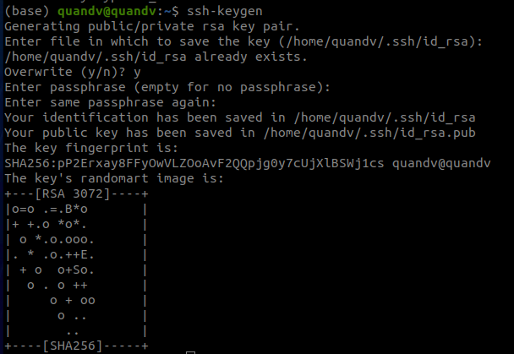
- Copy the content of your file `~/.ssh/id_rsa.pub` to GCP and press the blue button SAVE at the bottom of the page
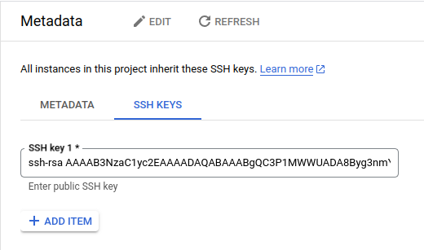
Note: To see the content of the file `~/.ssh/id_rsa.pub`, use the cat command
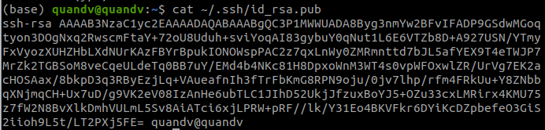
- Access your instance using the command `ssh -i ~/.ssh/id_rsa your_username@your_external_ip` as below
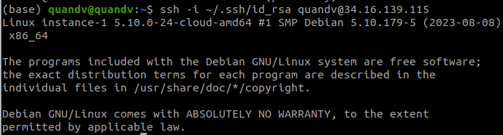
Note: To get the username, click the SSH KEYS tab again
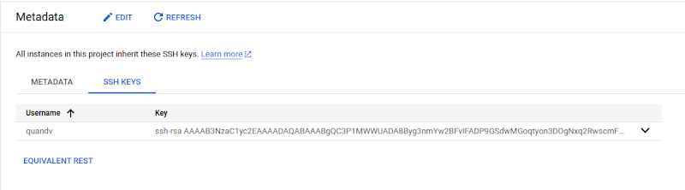
- Enjoy your new machine!
Note: If you want to have a UI instead of a terminal only, please follow this tutorial.
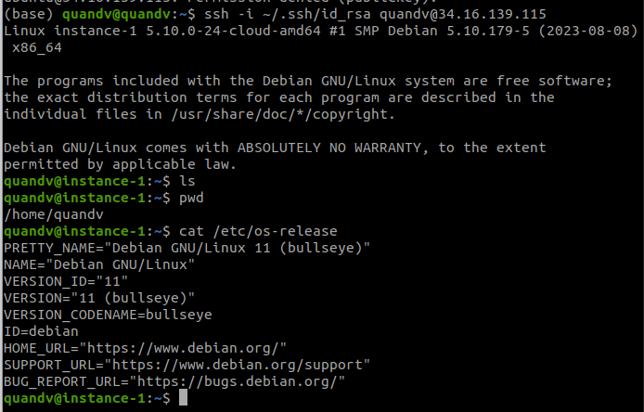
- Delete your machine by navigating to the VM instances tab, then clicking the 3 dots next to SSH and clicking Delete.
